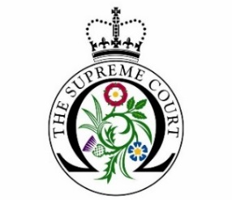

Educational guided tour booking form
For overseas education institutions, summer schools and commercial third parties

Name and address of educational institution:
Name and direct contact details of group organiser:
(if possible, please provide details that can be used on the day of your visit, in the event that we need to contact you with last minute information)
Date(s) and time(s) that you would like to visit:
(tours last around 45 minutes and can be scheduled to start between 10.00 to 12.00 and 14.00 to 16.00 Monday to Thursday)
What subject(s)/course(s) are your students studying?
How many people will be in your group, including staff?
(a maximum of 25 - 30 people permitted per tour)
Are there any specific areas or topics that you would like us to cover?
Do you have any other special requirements or questions?
Prices and Payment (please tick your preferred method of payment)
Single fee per group booking: £48.00 (£40 + VAT)

Credit/debit card (please call the education team on 0207 960 1500 to make a payment)

BACS transfer
Bank Name: Royal Bank of Scotland (RBS) Account Name: UK Supreme Court
Account number: 10001905 Sort Code: 60-70-80 IBAN: GB28NWBK60708010001905
Please use your institution/school name in the payment reference field, where available.

Please note all bookings are non-refundable (except in event of cancellation by the Supreme Court) and payment must be made in advance of the tour.

Would you be happy for our caterers to email you options for lunch available in the Supreme Court café during your visit?

Yes | No

