Meeting room catering request  External | 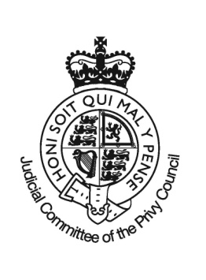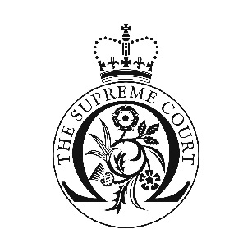
Case
Contact name
Organisation
Address
E-mail
Telephone
 | Date
Minimum charge £10 per service visit | Time
 |  | How Many | How Many | How Many
DRINKS | £
Coffee Jug 10 cups | 25.00
Tea Jug 10 cups | 25.00
Coffee Jug 5 cups | 13.00
Tea Jug 5 cups | 13.00
Still water per 1Ltr bottle | 3.00
Sparkling water per 1Ltr bottle | 3.00
Orange juice per jug | 5.00
Apple juice per jug | 5.00
Coke per person | 2.00
Diet Coke per person | 2.00
BISCUITS CAKES & PASTRIES per person
A selection from; Digestives, Garibaldis & Fig Rolls, Custard Creams & Bourbons. | 1.25
Breakfast pastries a selection from croissant, pain au chocolat & pain au raisin. | 3.50
A selection of cakes & pastries which may include; Portuguese custard tarts, chocolate cake, chocolate brownie, caramel shortbread, cookies & muffins many more. | 3.25
BREAKFAST & LUNCH per person
Please indicate the number of vegetarians in your meeting when ordering the following:
Bacon or Portobello mushrooms rolls | 4.00
Breakfast pots, yogurt, muesli & honey | 3.75
Sandwich lunch  Traditional sliced breads with a range of fillings including; cheese & tomato, ham & mustard, prawn mayonnaise, egg & cress & chicken salad. Served with crisps & fruit. | 9.95
Premium sandwich lunch  With a range of fillings including; smoked salmon & egg mayonnaise, chicken, poached salmon, & cream cheese with roasted vegetables. Served with crisps & fruit. | 11.25
Whole fresh fruit selection. | 2.50
SET PACKAGES per person Option 1 minimum 8 persons | 22.75
Tea/Coffee/Danish Pastry (upon arrival)
Lunch served at 1pm: Soup, Quiche, 2 Salads, Cheese board, Water/Juice, Fresh Fruits, Tea/Coffee
Option 2 minimum 8 persons | 20.50
Tea/Coffee/Bacon Rolls(upon arrival)
Lunch served at 1pm: Premium Sandwich platter with crisps, Water/Juice, Fresh Fruits, Tea/Coffee
Option 3 minimum 8 persons | 18.50
Mature cheddar & pickle, egg mayonnaise and smoked salmon sandwiches, mini cake selection, scones with clotted cream and strawberry preserve and tea
Notes
Orders are only confirmed when payment is received by telephone in advance by credit card.
Orders can only be accepted when you have a meeting room booked and with a minimum of two working days’ notice.
Orders can only be cancelled with two complete working days’ notice.
Receptions and buffets can be designed and quoted based on customer requirements.
Prices are inclusive of VAT.
All items may be subject to substitution due to availability.
Nuts and seeds are used in some of the facilities used for preparation and we cannot guarantee any items are nut or seed free.
Breakfast service will be delivered to the room as close to 0900hrs as possible and lunch service as close to 1300hrs as possible.
Please note that food and drink from external suppliers is not permitted within the court building.
Email to catering@supremecourt.uk

