Meeting room request  for professional court users | 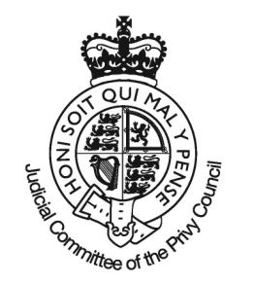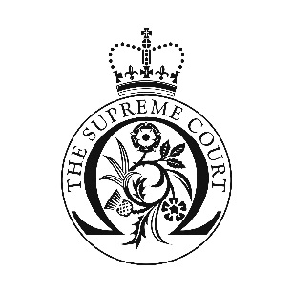
Case
Start date
First day of use
Total days required
Cost per day £162 including VAT
Your Details
Name
Organisation
E-mail
Telephone
Bookings
May be made a maximum of three weeks prior to the case commencement.
Are not confirmed until we have contacted you by telephone and successfully taken payment by credit card.
May only be made by completing and emailing this form to catering@supremecourt.uk
Will be allocated a room based on availability and this is subject to change.
Rooms are available between 0830 and 1630 on days the Court is sitting and is subject to the Court’s normal access procedures.
Rooms not required (i.e. when cases finish at least one full day earlier than listed) can be refunded upon application to the catering provider up to 6 weeks after the date for which they were booked. Refunds will be made to the credit card that was used to make the initial booking.
Are managed on behalf of the Court by Zafferano Concessions, their catering provider.
Telephone 020 79601979.

Catering services
A range of catering is available to your meeting room this must be ordered in advance using the catering order form available from the Court’s web site.
Once ordered catering can only be cancelled with two complete working days’ notice.
There is a full café service available during the opening hours of the Court.
Please note that food and drink from external suppliers is not permitted within the court building.
Security
The meeting rooms are in the public area of the Court and the Court accepts no liability for the security or confidentiality of any items left in the meeting room. You are advised to take care of all valuable or confidential items at all times. Nothing may be left in the meeting room overnight.
When you arrive please ask at the main entrance reception desk for your room to be unlocked.

Email to catering@supremecourt.uk

